**EXAMEN KEUZEDEEL**

**BASIS PROGRAMMEREN VAN GAMES**

**K0788**

**BIJLAGE 1 VOOR DE KANDIDAAT  
GAME DESIGN DOCUMENT**

**Dit examen is ontwikkeld door Bob van den Berge, coach bij de Bit Academy, en Joey Schmitz, docent Software Development bij ROC van Flevoland. Onze dank gaat uit naar Lincy Ellermeijer, game developer en docent Game Development bij de HvA, voor haar hulp bij het ontwikkelen van het theoretische deel van de lesstof.**

# **GAME DESIGN DOCUMENT**

| **Project Concept** | | | |
| --- | --- | --- | --- |
| **1** **Player Control** |  | You control a   | *paddle* | | --- | | in this   | *breakout* | game | | --- | --- | |
|  | where   | *keyboard arrows (left/right)* | | --- | | makes the player   | *move the paddle horizontally.* | | --- | |

| **2** **Basic**  **Gameplay** |  | During the game,   | *a ball and bricks* | appear | | --- | --- | | from   | *the bottom of the screen* | | | --- | --- | |
| --- | --- | --- | --- | --- | --- | --- | --- |
|  | and the goal of the game is to   | *break all the bricks by bouncing the ball with the paddle without losing all of your lives.* | | --- | | |

| **3** **Sound**  **& Effects** |  | There will be sound effects   | *Game Over: A sad or dramatic sound effect when the player runs out of lives.*  *Level Complete: A cheerful "victory" sound when all bricks are destroyed.* | | | --- | --- | | and particle effects   | *Ball Hits Brick: A small explosion of particles when a brick is destroyed.*  *Level Complete: A celebratory burst of particles when all bricks are cleared.* | | | --- | --- | |
| --- | --- | --- | --- | --- | --- | --- | --- |
|  | [*optional*] There will also be   |  | | | --- | --- | | |

| **4** **Gameplay**  **Mechanics** |  | As the game progresses,   | *power ups (multi-ball and health regeneration) will become available* | | | --- | --- | | making it   | *more easy or difficult depending on the power up.* | | | --- | --- | |
| --- | --- | --- | --- | --- | --- | --- | --- |
|  | [*optional*] There will also be   |  | | | --- | --- | | |

| **5** **User**  **Interface** |  | The   | *score and lives* | | --- | | will   | *increase and decrease* | | --- | | whenever   | *breaking a brick and losing a ball to change score and lives.* | | | --- | --- | |
| --- | --- | --- | --- | --- | --- | --- | --- | --- |
|  | At the start of the game, the title   | *“Best Education”* | will appear | | --- | --- | | | and the game will end when   | *all bricks are destroyed or the player runs out of lives.* | | | --- | --- | |

| **6** **Other Features** |  | | *You can pause the game at any time.* | | | --- | --- | | |
| --- | --- | --- | --- | --- | --- |

# **Project Timeline**

| **Milestone** | **Description** | **Due** |
| --- | --- | --- |
| **#1** | | * *Configure the physics of the paddle, ball and bricks* | | --- | | | *04/07* | | --- | |
| **#2** | | * *Implementing the lives of the player* * *Implementing the score system* | | --- | | | *04/08* | | --- | |
| **#3** | | * *Implementing the win and lose conditions to the game* | | --- | | | *04/08* | | --- | |
| **#4** | | * *Implementing the sound effects* | | --- | | | *04/10* | | --- | |
| **#5** | | * *Implementing a game over screen when the player loses all of his lives* * *Implementing a win screen for when the player breaks all the bricks* | | --- | | | *04/16* | | --- | |
| **Backlog** | | * *Implementing the pause and resume conditions to the game* * *Implementing power ups to the game* | | --- | | | *04/18* | | --- | |

# **Project Sketch**

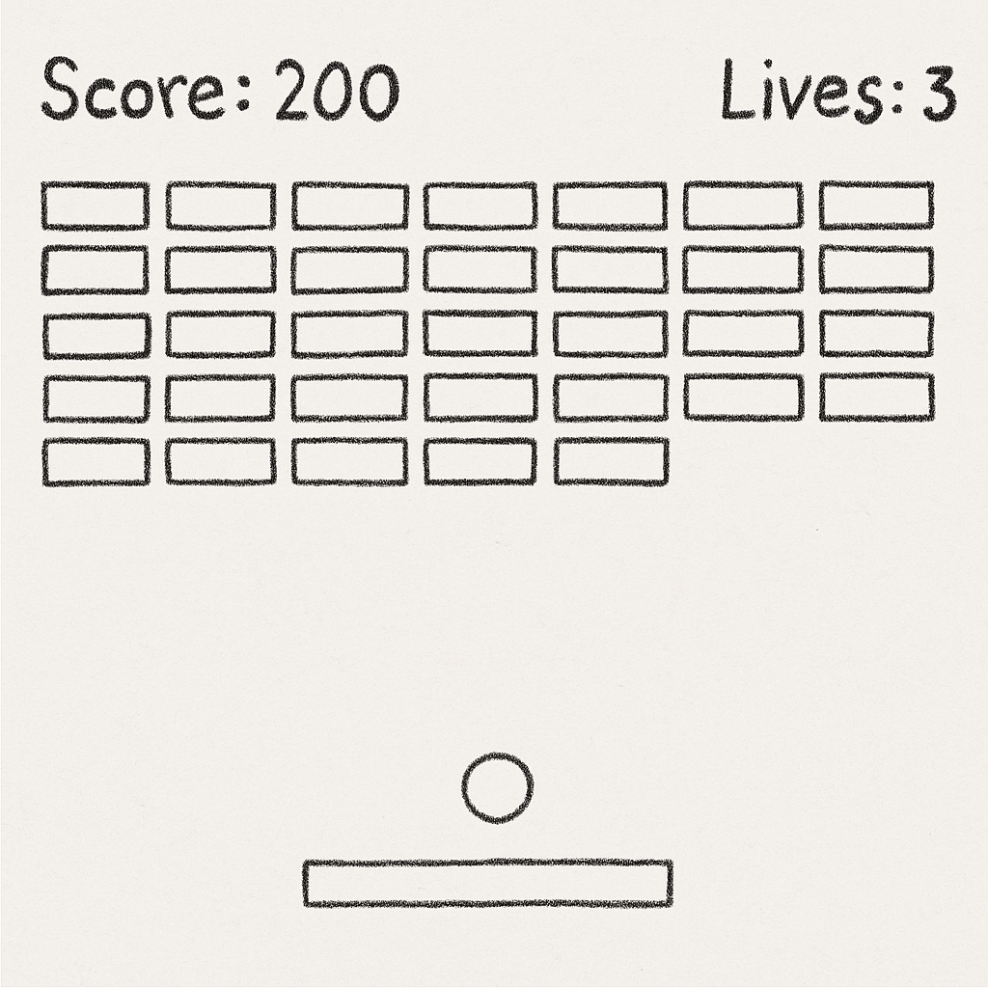

# **Technieken**

Game Engine: Phaser

Platform: Web-based

Programmeertaal: JavaScript en PHP

**Waarom?**  
Ik heb gekozen voor Phaser omdat het perfect is voor 2D-browsergames en omdat het ingebouwde physics heeft, wat voldoende is voor een Breakout-game. JavaScript gebruik ik omdat Phaser hierop is gebaseerd, en PHP ga ik inzetten voor een inlogsysteem en de leaderboard.

# **Feedback**

[demo](https://youtu.be/RBgowh1zBY4)

Dankzij Emanuels feedback heb ik het probleem opgelost waarbij de bal soms horizontaal bleef bewegen. Daarnaast gaf hij het advies om meer rijen blokken toe te voegen, wat zorgt voor een langere en uitdagendere spelervaring.